**New Codington Festival Online Project -   
Site Map**

**Project:** New Codington Festival Online Project

**System:** Festival Event Registration System – Release 2

Table of Contents

1 Site Map 2

1.1 Structure 2

1.2 Page Descriptions 3

2 Navigation Model 4

2.1 Portal Page Navigation (Structure and Links) 4

2.1.1 Global Navigation Types 4

2.2 FERS Pages: Navigation Summary 5

2.3 Detailed UI flow 6

# Site Map

## Structure



**NOTE**: The Festival Portal Page has the ‘Register’ and ‘UnRegister’ hyperlinks for visitors to register to and unregister from an Event.

## Page Descriptions

|  |  |
| --- | --- |
| **Screen** | **Description** |
| Portal Login Page | The site front page. From this page a new visitor can register and an already registered visitor can login. |
| New Visitor Registration Page | Page where a user can register for a FERS visitor account. |
| Update Visitor Information Page | A registered visitor can update their personal information. |
| Festival Portal Page | Displays the visitor’s profile, a table listing events that the visitor has already registered for (and can unregister from, if necessary) and another table listing events that are available – this table also includes Search and Sort Events functionality. |
| Event Catalog Page | Displays the complete list of known upcoming events  This page also includes Search and Sort Events functionality.  This page also provide delete event functionality for admin users |
| Add/Update Event Page | Page where admin users can insert and update events. |
| About Page | Static page with information about FERS. |

# Navigation Model

## Portal Page Navigation (Structure and Links)

### Global Navigation Types

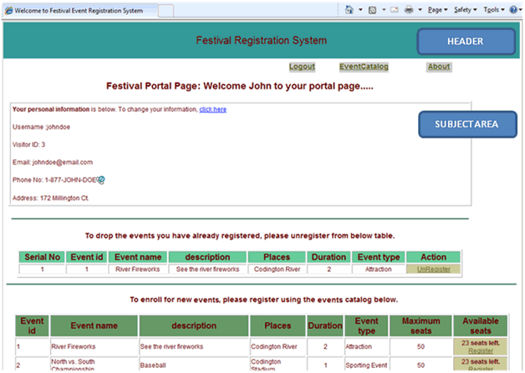

#### Links

Embedded links offer a means to navigate to another page. When the visitor moves the mouse over a link the text changes color to indicate that it can be selected. If the visitor presses the left mouse button while the link is highlighted, the visitor will navigate to that page. Links can be embedded in the header, the left navigation pane, the subject area or in the footer.

## 

## FERS Pages: Navigation Summary

|  |  |
| --- | --- |
| **Page Name** | **Navigation Requirements** |
| Login Page | The site front page. Here a user can register for a visitor account or a registered visitor can login to FERS.  While on any page in FERS (after a successful login), the visitor may logout by clicking the ‘Logout’ link on the top right corner of the page and return to this page. |
| Register Visitor Page | Clicking on the ‘Register here’ hyperlink on the Login Page will take the user to this page, where the user can register for a visitor account on FERS. |
| Festival Portal Page | After a successful login, the visitor is taken to the Festival Portal page.  This page displays the details of the visitor, any events that the visitor has already registered for (and can unregister from, if necessary) and a section showing a list of upcoming events (with Search and Sort functionality). |
| Event Catalog Page | After a successful login, a visitor can go to the Event Catalog page by clicking on the ‘Event Catalog’ link on the top right corner of the Festival Portal page. This page, displays the complete list of upcoming events (with Search and Sort functionality).  Admin user can also delete events. |
| Add/Update Event Catalog Page | After a successful login, a visitor can go to the Event Catalog page by clicking on the ‘Event Catalog’ link on the top right corner of the Festival Portal page. There is an Add Event link on this page which allows user to add and update events  Admin user can also insert and update. |
| Update Visitor Information Page | After a successful login, a visitor can update their personal information by clicking on the ‘click here’ link near the top and center of the Festival Portal page. |
| Errors | Error messages are either in-line on the page or in pop-up dialog boxes. No separate error pages are available |
| About Page | After a successful login, a visitor can go to the About page by clicking on the ‘About’ link on the top right of the Festival Portal page. Thispage contains information about FERS. |
| Update Visitor Information Page | After a successful login, a visitor can update their personal information by clicking on the ‘click here’ link near the top and center of the Festival Portal page. |
| Errors | Error messages are either in-line on the page or in pop-up dialog boxes. No separate error pages are available |

## Detailed UI flow

The **Detailed UI flow** shown below explains the Festival Event Registration System from a Development perspective.

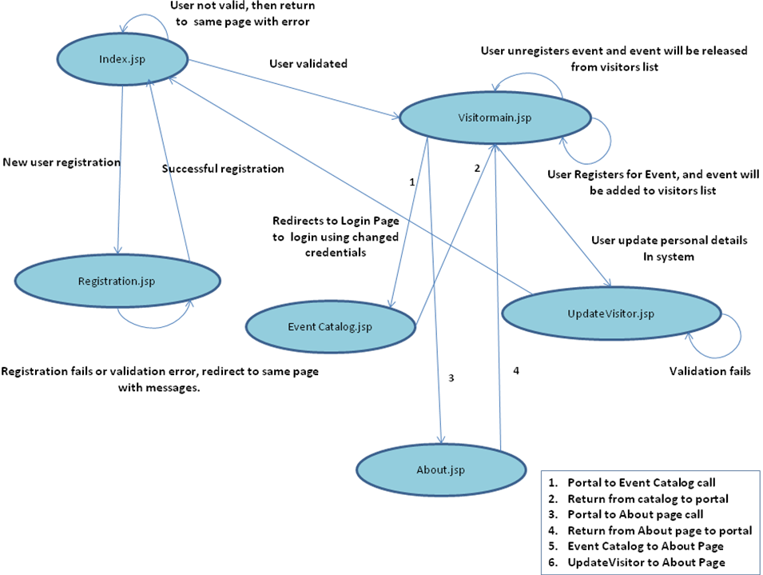

Please note that the diagram above doesn’t include the information that the ‘logout’ link returns the visitor to the ‘Index.jsp’ login page from any page. Also see the Site Map section above which is used to describe the various navigation elements as well.